**Project Design Phase-II**

**Data Flow Diagram &User Stories**

|  |  |
| --- | --- |
| Date | 03October 2022 |
| Team ID | PNT2022TMID44408 |
| Project Name | Intelligent Vehicle Damage Assessment and Cost Estimator for Insurance Companies |
| Maximum Marks | 4 Marks |

**Data Flow Diagrams:**

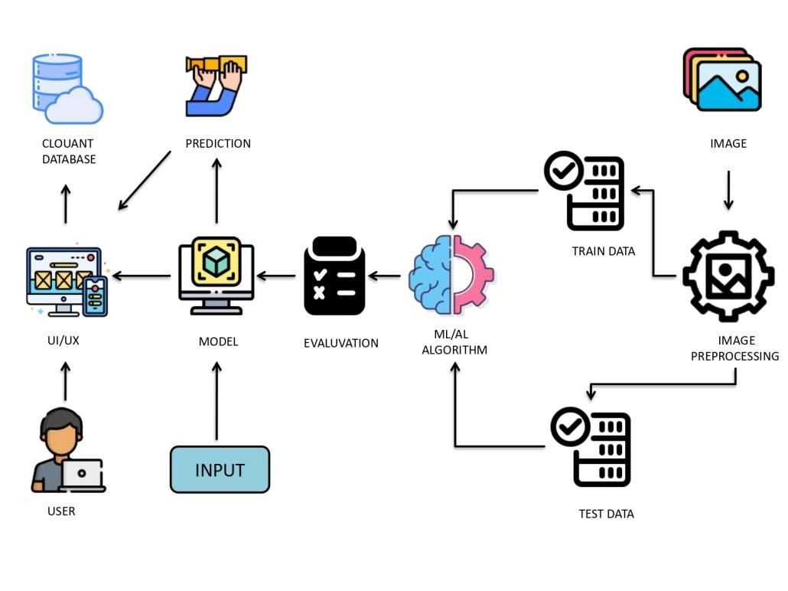

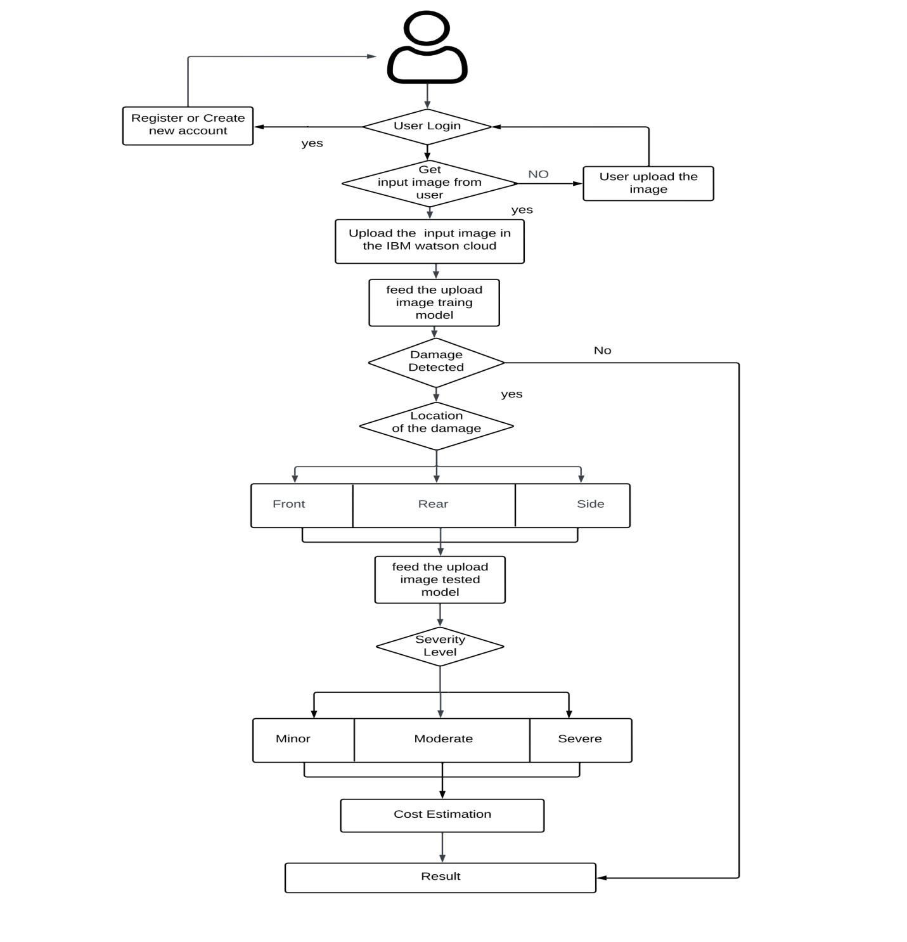

**User Stories**

Use the below template to list all the user stories for the product.

|  |  |  |  |  |  |  |
| --- | --- | --- | --- | --- | --- | --- |
| **User Type** | **Functional**  **Requirement**  **(Epic)** | **User Story Number** | **User Story / Task** | **Acceptance criteria** | **Priority** | **Release** |
| Customer  (Mobile user) | Registration | USN-1 | As a user, I can register for the application by entering my email, password, and confirming my password. | I can access my account / dashboard by entering valid credentails | High | Sprint-1 |
| Customer  Details | Login | USN-2 | As a user, I will receive confirmation email once I have registered for the application | I can receive confirmation email & click confirm | High | Sprint-1 |
| Customer Uses | Dashboard | USN-3 | As a user, I can register for the application through Facebook | I can register & access the dashboard with Facebook  Login | Low | Sprint-4 |
| Customer Options | Details about insurance companies | USN-4 | As a user, I can register for the application through Gmail | I can register & access the dashboard with Facebook Gmail | Medium | Sprint-1 |
| Customer usage | Login | USN-5 | As a user, I can log into the application by entering email & password | I can log in and view my dashboard at my demand on any time | High | Sprint-1 |
| Customer needs to do | Dashboard | USN-6 | As a user I must capture images of my vehicle and upload it into the web portal | I can capture the entire vehicle and upload | High | Sprint-2 |
| Customer (Web user) | Details about estimated cost based on damage | USN-7 | As a user I must receive a detailed report of the damages present in the vehicle and the cost estimated | I can get the estimated insurance cost | High | Sprint-3 |
| Customer Care Executive | Details about  Estimated cost  Based on damage | USN-8 | As a user, I need to get support from developers in case of queries and failure of service provided | I can have smooth user experiences and all the issues raised is sorted | Medium | Sprint-4 |
| Administrator | Details about  Estimated cost  Based on damage | USN-9 | We need to satisfy the customer needs in an efficient way and make sure any sort of errors are fixed | I can finish the work without any problems | High | Sprint-4 |